# **Name: Abdurrahman Qureshi**

# **Roll No: 210451**

Practical No: 7

**QUESTION |**

**1)Display employees in sales department with its location.**

**OUTPUT:**

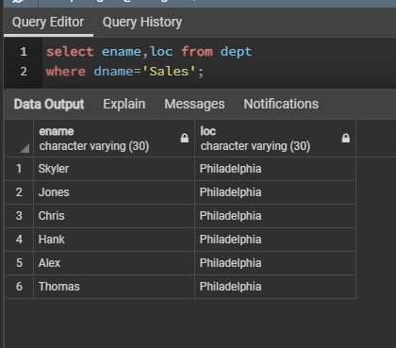

2.)Display Max & Min salary of employee**s.**

**OUTPUT:**

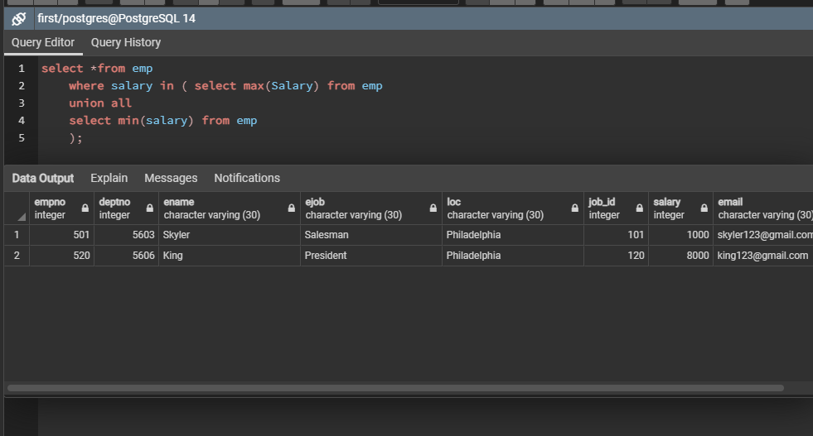

**3)Display total salary of employees working in Analysis department with dept_no and location of the department.**

**OUTPUT:**

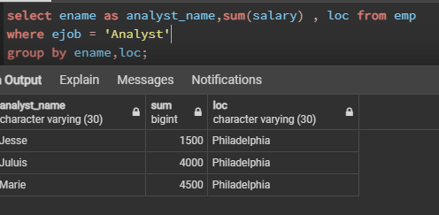

**4.)List employees with hire date in format of ‘jan 19 2018’.**

**OUTPUT:**

